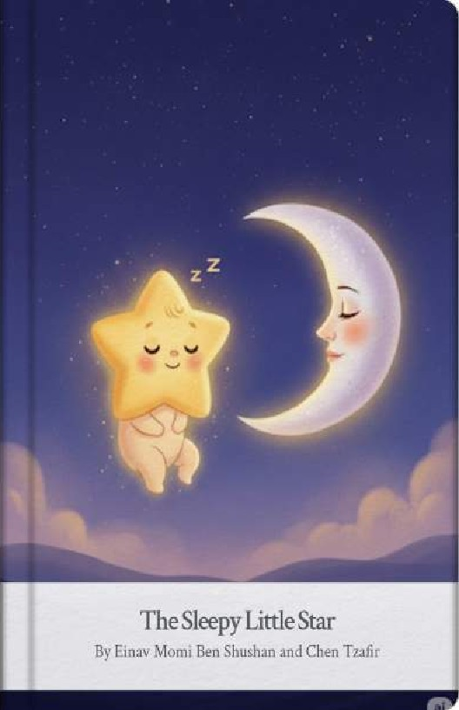
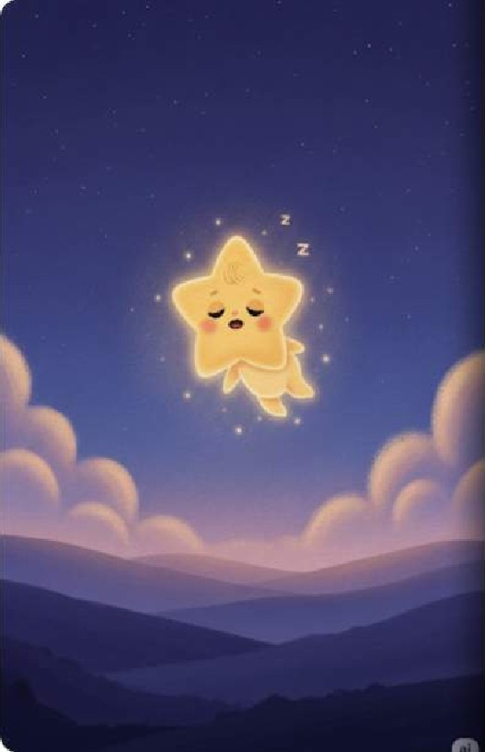
High åbove the world, where thewelvet sky meets the purple hills, lived a little -star named Pip, Pip was very bright and veryround, but most of all, Pip was very, very sleepy.
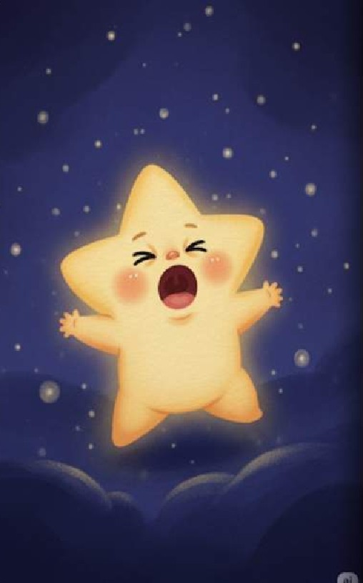
Pip gave a giant, wobbly yawn, "Hooaaa-mmm," he sighed. His points stretched out wide, reaching for the corners of the night, but he just couldn't find a place to tuck himselfin.
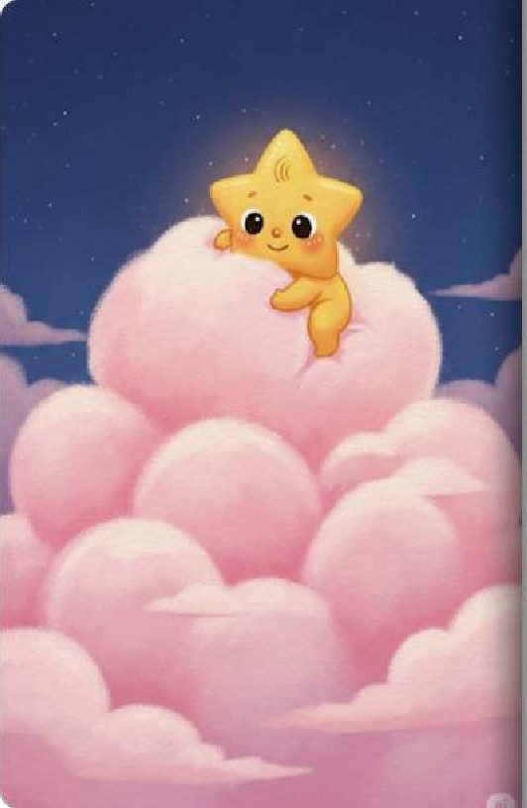
He saw a cloud drifting by, as soft as a marshmallow and as pink as rose, Pip hopped onto che cloud and tried co snuggle deep into its fluff.
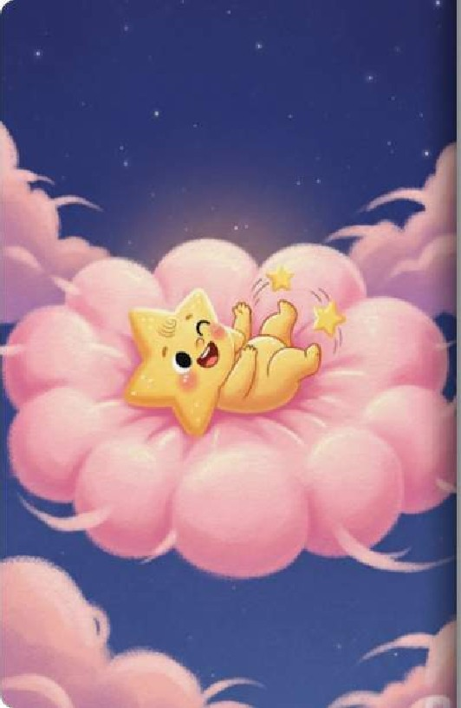
"He-he-he!" Pip giggled, The cloud was far too tickly! Every time Pip moved, the wispy edges ofthe cloud tickled his tummy and made him wiggle, He couldn^{r}t sleep there.

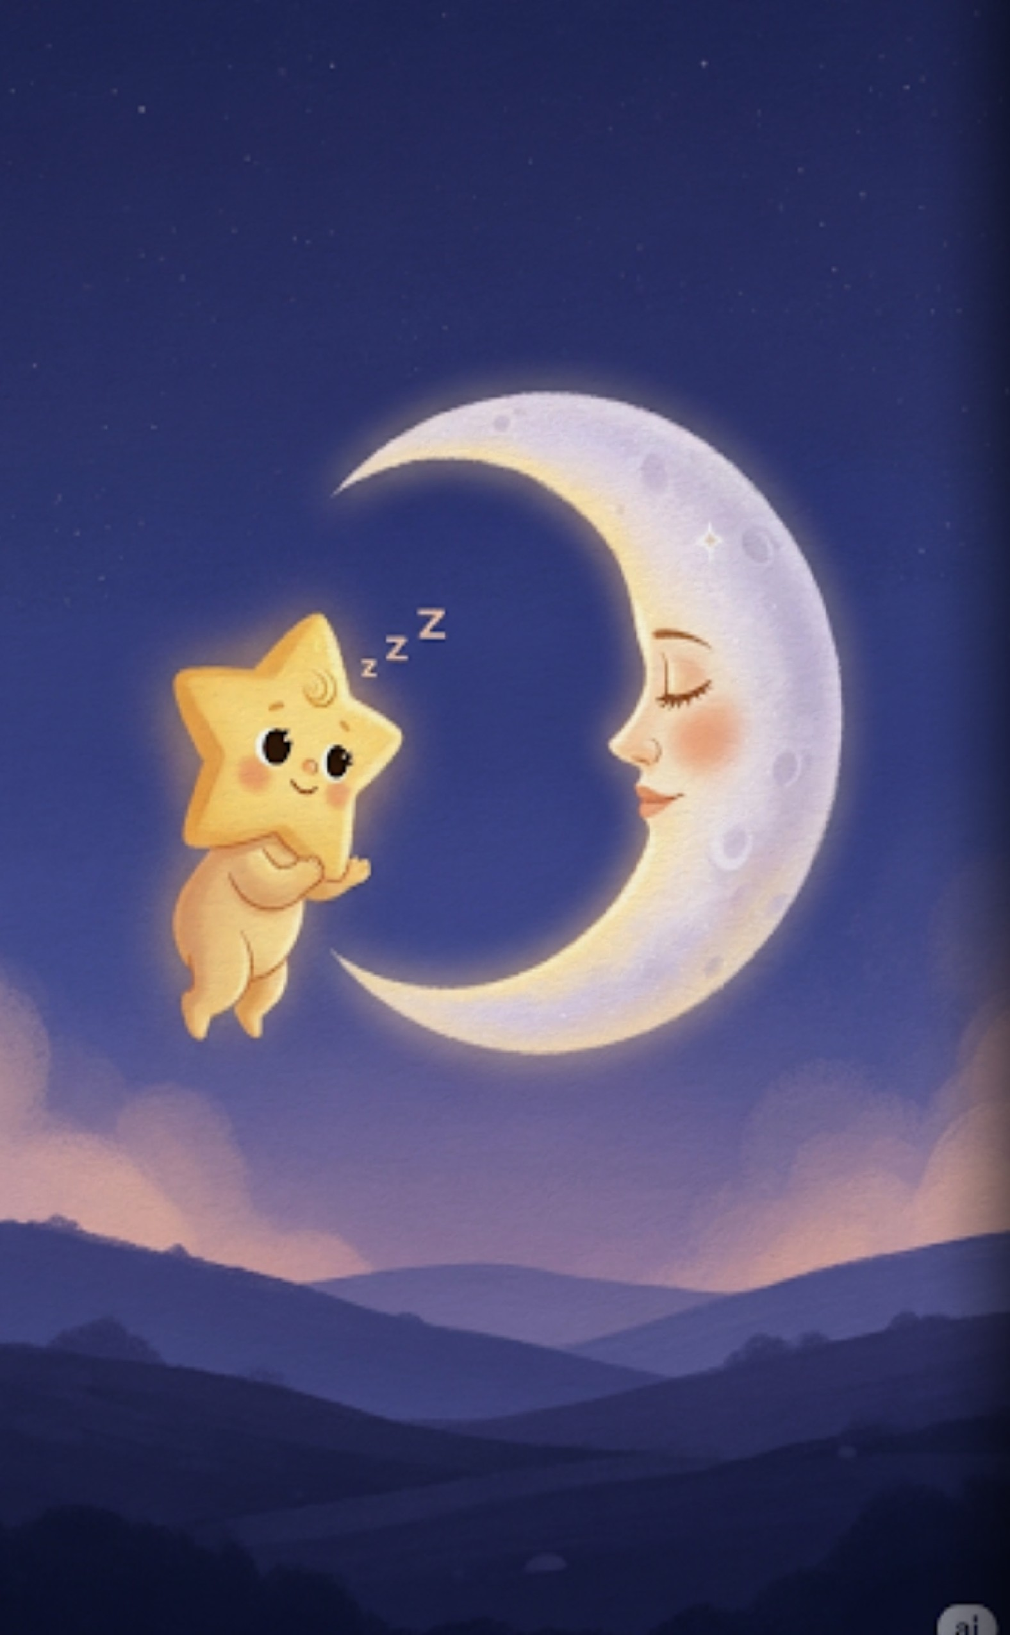
Then, Pip saw Mona the Moon, She was a silver crescent, shining With a calm and steady light, "Mona," Pip whispered, ^{H}I am so sleepy Can you help me find my bed?"

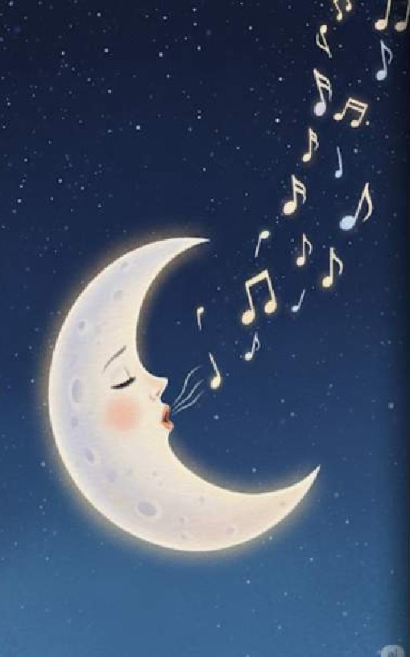
Mona smiled a silver smile and began to hum a low, sweet melody The sound was like a warm blanket wrapping around che stars. Mona sang, night is quiet. The world is dreaming.
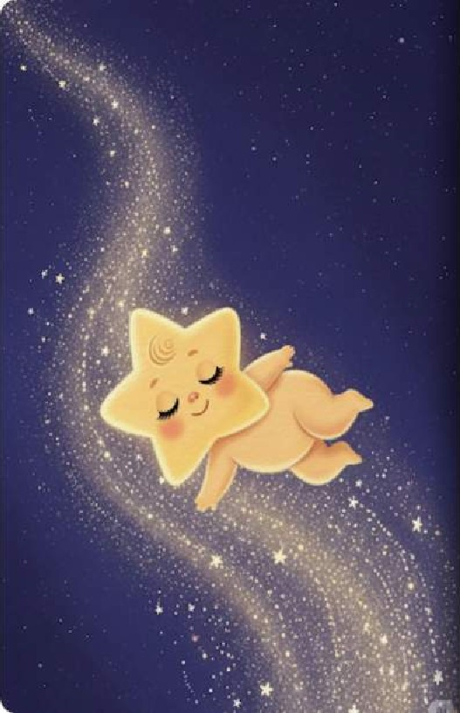
Pip felt his heavy eyes start to close. HO drifted away from the tickly cloud and moved slowly through the silent ajr , following the sound of Mona's song.
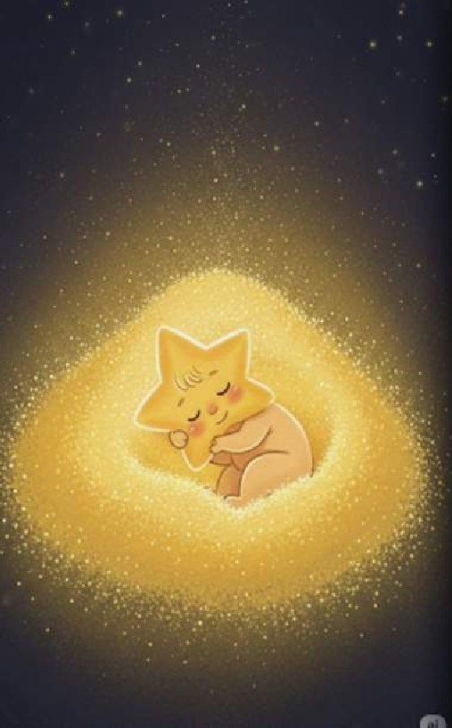
He found a secret corner of the sky, filled With a bed Of shimmering golden dust. It was warm, still, and perfectly quiet. Pip curled up right in the middle Ofthe gold.
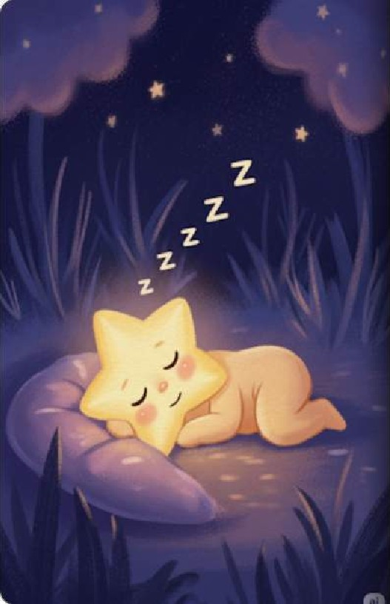
The sky was still, The stars were dimEverything was COZY and calm. NOW it is time for you to close your eyes, just like Pip, and dream of the beautiful night. Goodnight.
10

